EXPERIMENT NO. 3

Deploying Multi-Service Applications Using Docker Compose

LO4: Containerization, orchestrate and deploy applications using Docker, Compose, Kubernetes and Cloud infrastructure tools.

Aim
To understand the concept of multi-container orchestration and to deploy a multi-service application consisting of a Nginx web server and a MySQL database using Docker Compose, covering service definition, environment configuration, networking, and volume persistence.

Software Requirements
- Windows 10/11 (64-bit)
- Docker Desktop (includes Docker Compose)
- WSL2 (Windows Subsystem for Linux)
- PowerShell / Command Prompt
- Text Editor (Notepad / VS Code)
- Active Internet Connection
- Web Browser

Theory

What is Docker Compose?
Docker Compose is a tool provided by Docker for defining and running multi-container applications. Instead of manually creating and linking multiple containers using separate 'docker run' commands, Compose allows all services, networks, and volumes to be declared in a single YAML file (docker-compose.yml). A single command can then be used to start, stop, or rebuild the entire application stack.

Why Multi-Service Applications?
Modern applications are rarely single-process systems. A typical web application requires a front-end/web server, a back-end application server, and a database, each of which may need to scale, restart, or be updated independently. Running each component as its own container, while connecting them through a shared Compose-managed network, mirrors real-world microservice architecture and simplifies development, testing, and deployment.

Key Concepts in Docker Compose
    - Services — each entry under 'services:' represents one container (e.g., web, database).

    - Image — the base image used to create the container for a service.
    - Ports — mapping of host machine ports to container ports (HOST:CONTAINER).
    - Environment Variables — used to configure containers at runtime (e.g., database credentials).
    - Volumes — persistent storage that survives container removal, used here for MySQL data.
    - Networks — Compose automatically creates a shared network so services can communicate using their service names as hostnames.

Structure of docker-compose.yml
The Compose file follows YAML syntax and is organized under top-level keys: 'version' (Compose file format version), 'services' (list of containers to run), and 'volumes' (named volumes for persistent storage). Each service can specify its image, container name, ports, environment variables, and volume mounts.

Advantages of Docker Compose
    - Single command to start/stop an entire multi-container application.
    - Declarative configuration — the whole stack is defined in one version-controlled file.
    - Automatic internal networking between services using service names.
    - Simplified environment variable and volume management.
    - Easier to reproduce identical environments across machines.

Setup and Configuration
The following steps describe how to set up the project directory and Compose file.
- Open PowerShell / Command Prompt.
- Create a new directory for the project:


- Navigate into the newly created directory:

- Open Notepad (or any text editor) to create the Compose file:

- Paste the following YAML configuration into the file:

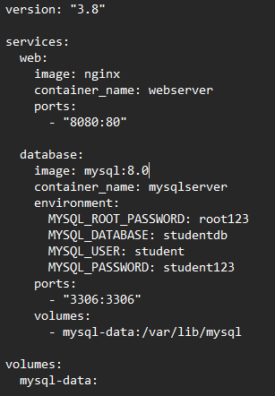

- Save the file. In Notepad's 'Save As' dialog, set 'Save as type' to 'All Files' and name it exactly 'docker-compose.yml' , saving it inside the compose-demo directory.
- Verify the file was created correctly by listing directory contents:

dir

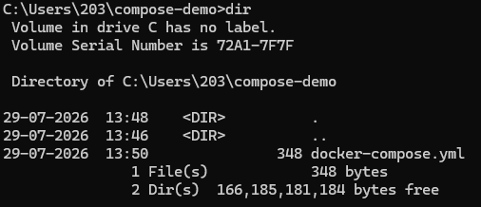

Commands Used

Command | Description
docker compose up | Start all services defined in the Compose file

Command | Description
docker compose up -d | Start all services in detached (background) mode
docker compose ps | Show status of running services
docker compose logs | View logs of all services
docker compose stop | Stop running services without removing them
docker compose start | Restart previously stopped services
docker compose restart | Restart containers for all services
docker compose down | Stop and remove containers, networks created by up
docker compose down -v | Stop and remove containers, networks, and volumes
docker compose images | Show images used by the created containers
docker compose config | Validate and view the resolved Compose file

Procedure
The steps below were carried out in sequence, all from within the compose-demo directory in PowerShell
/ Command Prompt, to deploy and manage the multi-service application:

# | Command | Explanation | Expected Output
1 | mkdir compose-demo | Create project directory. | Directory created.
2 | cd compose-demo | Move into project directory. | Prompt path changes to compose-demo.
3 | notepad docker-compose.yml | Create and edit the Compose file. | Notepad opens a new file.
4 | (paste YAML, save as 'All Files') | Define web (nginx) and database (mysql) services. | File saved as docker-compose.yml.
5 | dir | Verify docker-compose.yml exists in the folder. | docker-compose.yml listed.
6 | docker compose config | Validate YAML syntax before starting. | Resolved configuration printed, no errors.
7 | docker compose up -d | Build/pull images and start both services in background. | Both containers created and started.
8 | docker compose ps | Confirm both containers are running. | webserver and mysqlserver shown as 'running'.

# | Command | Explanation | Expected Output
9 | Browser -> localhost:8080 | Access the Nginx service via mapped port. | Nginx welcome page loads.
10 | docker compose logs | View combined logs of both services. | Logs from web and database services shown.
11 | docker exec -it mysqlserver mysql -u student -p | Connect to MySQL inside the database container. | Prompted for password; MySQL shell opens.
12 | SHOW DATABASES; | Verify studentdb was created via environment variables. | studentdb listed among databases.
13 | docker compose stop | Stop both running services. | Containers stop, status 'Exited'.
14 | docker compose start | Restart the stopped services. | Containers return to 'running' state.
15 | docker compose down | Stop and remove containers and network (volume persists). | Containers and network removed.
16 | docker compose up -d | Bring the stack back up to verify data persistence. | studentdb still present due to named volume.
17 | docker compose down -v | Clean up completely, including the volume. | Containers, network, and volume all removed.

Screenshots
Insert relevant screenshots for each stage of execution below.

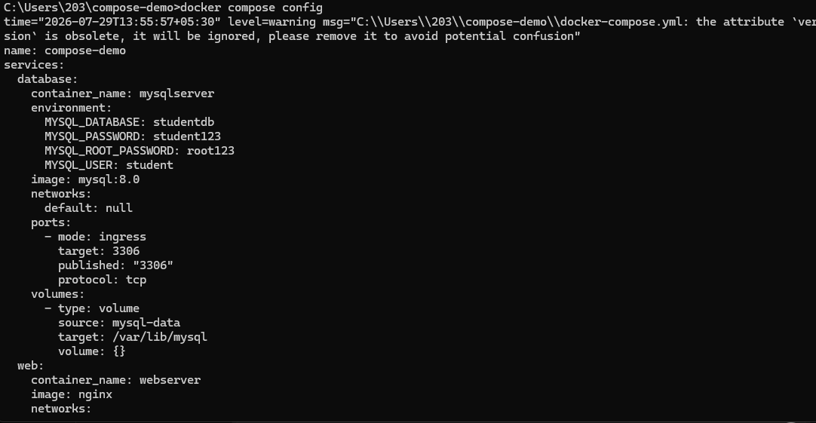
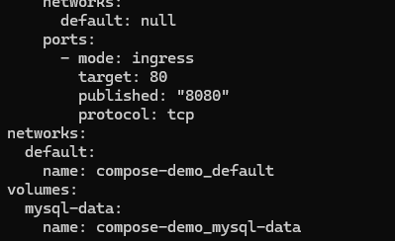

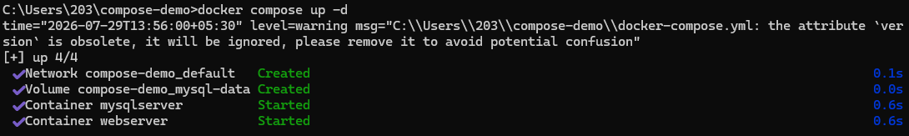

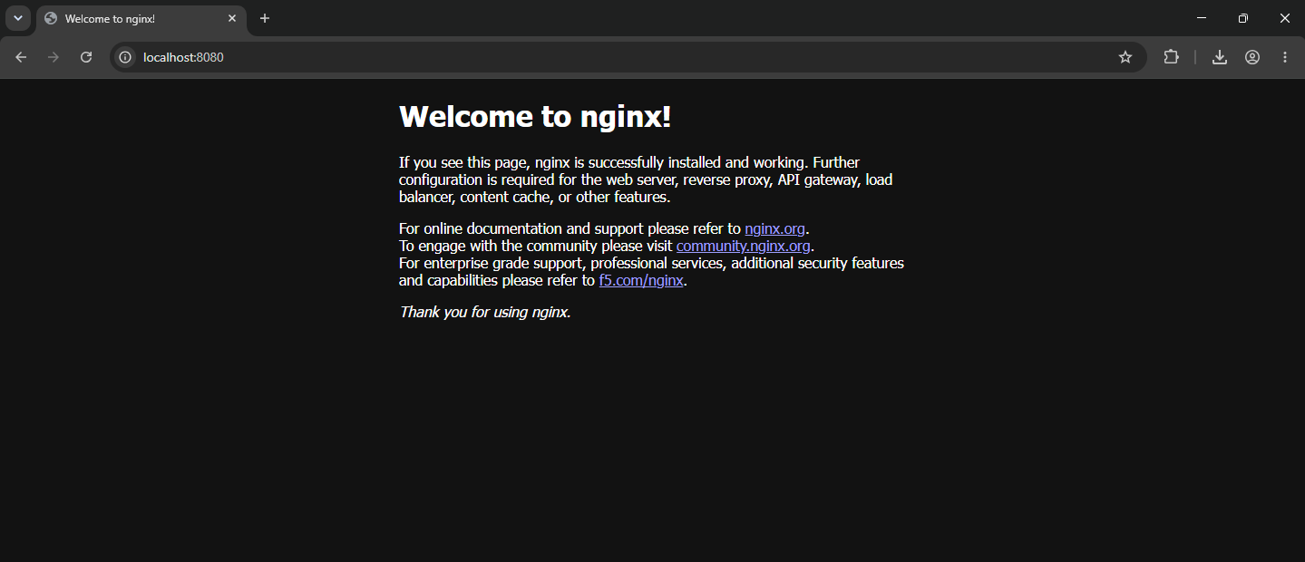
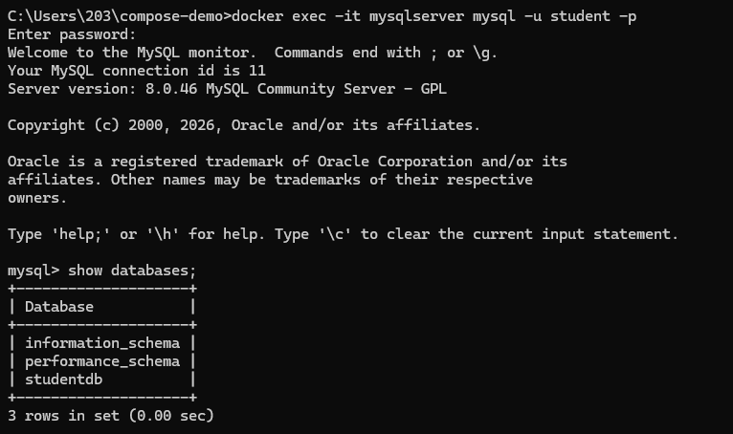

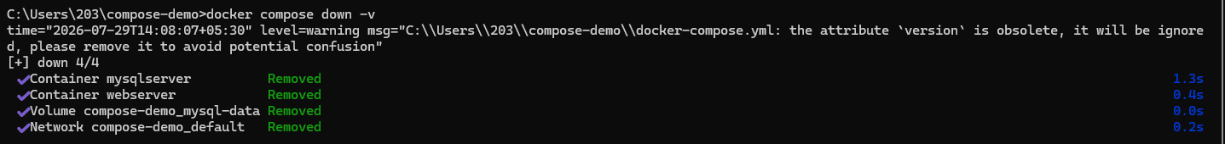

Observation
The experiment demonstrated that Docker Compose offers a more streamlined and efficient method for managing multi-container applications than manually executing separate docker run commands for each service. Both the Nginx web server and the MySQL database were deployed, networked, and configured through a single YAML configuration file, making the setup process simple and consistent. The Nginx service was successfully accessed via the mapped host port, while the MySQL container was initialized with the required database, username, and password using environment variables. Additionally, the use of a named volume ensured that database data remained intact even after the containers were stopped and removed with docker compose down. When the docker compose down -v command was executed, both the containers and the associated volumes were removed, resulting in a complete cleanup of the application's resources.

Result
A multi-container application comprising an Nginx web server and a MySQL database was successfully deployed using Docker Compose. Both services were launched simultaneously with a single command, and their functionality was verified to ensure proper operation. The complete lifecycle of the application—including starting, stopping, restarting, and removing the services—was managed collectively, demonstrating the effectiveness of Docker Compose in orchestrating and managing interconnected containers.

Conclusion
This experiment offered hands-on experience in managing multi-container applications using Docker Compose. It demonstrated how a single YAML configuration file can be used to define and manage multiple interconnected services, including their images, port mappings, environment variables, and persistent storage. Unlike manually handling individual containers, Docker Compose simplifies deployment and management while providing a consistent and version-controlled approach to configuring an entire application stack. The experiment also highlighted the role of volumes in ensuring data persistence and showed how Docker Compose automatically creates networks that enable seamless communication between services. Overall, it emphasized the efficiency of deploying, scaling, and removing related services as a unified application, which is an essential practice in modern DevOps and microservices-based environments.

